1. Mentor will explain in NodeJS and Java but I will document only for Java.   
   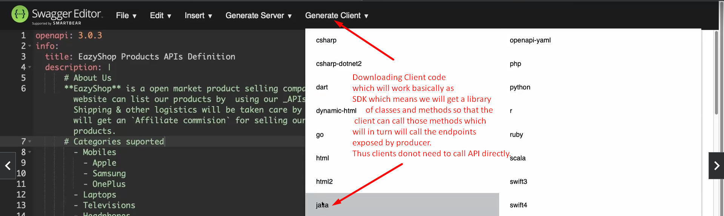
2. 
3. 